*Semester One, 2018*

Question and Answer Booklet

**Year 10**

**Year 10**

**Science**

***Time allowed for this paper***

Recommended Reading time: Ten minutes

Working time for paper: Fifty minutes

***Materials required/recommended for this paper***

This Question/Answer Booklet

Multiple-choice Answer Sheet

Periodic table

**Students to provide:**

Standard items: pens, pencils, eraser, ruler, highlighters

Special items: non-programmable calculators satisfying the conditions set by the School

No other items may be taken into the examination room. It is your responsibility to ensure that you do not have any unauthorised notes or reference material. If you have any unauthorised material with you, hand it to the supervisor before reading any further.

Student Name: ________________________________

Class: _________

***Structure of this paper***

This paper requires students to answer 26 questions. The highest possible mark is 44. The candidate’s examination percentage will be calculated on the basis of the fraction of 44 examination marks scored by the candidate.

|  |  |  |  |  |
| --- | --- | --- | --- | --- |
| **SECTION** | **No. of questions available** | **No. of questions to be attempted** | **Suggested working time**  **(minutes)** | **Marks available** |
| Section 1:  **MULTIPLE CHOICE** | 15 | 15 | 20 minutes | 15 |
| Section 2:  **SHORT ANSWER** | 6 | 6 | 30 minutes | 29 |

***Instructions to candidates***

1. Answer the questions according to the following instructions.

Section One: Answer all questions on the separate Multiple-choice Answer Sheet provided. For each question cross the box to indicate your answer. Use only a blue or black pen to shade the boxes..

Section Two:  Write your answers in the space provided in this Question/Answer Booklet. Wherever possible, confine your answers to the line spaces provided. Use a blue or black pen (**not** pencil) for this section.

**SECTION ONE - MULTIPLE CHOICE** [15 marks]

This section has **15** questions. Answer **all** questions on the separate Answer Sheet provided. ____________________________________________________________________________________________________________

1. Chromosomes are found in the nucleus of:

1. most cells of the body
2. brain cells only
3. gametes only
4. stem cells that have not yet differentiated

2. What is the name given to an individual whose alleles are the **same** for a characteristic?

1. heterozygous
2. homozygous
3. monohybrid
4. homologous

3. If a diploid cell in a plant has 32 chromosomes, how many chromosomes will be in each gamete?

1. 32
2. 30
3. 16
4. 14

4. An allele is best defined as

1. a lethal recessive phenotype
2. a lethal dominant phenotype
3. a type of gene found only on the sex chromosome
4. an alternative form of gene at a given position on the chromosome.

5. The structure of DNA may be described as a twisted ladder. Recall what forms the upright parts of the ladder.

1. alternating sugar and phosphate units
2. nitrogen bases
3. amino acids
4. proteins

6. The periodic table:

1. is a systematic chart listing all known elements
2. arranges elements from lowest to highest atomic number
3. arranges elements in columns called groups
4. all of the above

7. An atom has a mass number of 27. It therefore has:

1. 13 protons, 14 neutrons and 14 electrons
2. 13 protons, 14 neutrons and 13 electrons
3. 14 protons, 14 neutrons and 14 electrons
4. 13 protons, 13 neutrons and 13 electrons

8. Which of the following is a noble (inert) gas?

1. Oxygen
2. Chlorine
3. Neon
4. Hydrogen

9. Which of the following is the **most** reactive metal element?

1. potassium
2. iron
3. aluminium
4. steel

10. Nitrogen is in period 2, group 15. Which of the following elements would have the most **similar** properties to nitrogen?

1. Phosphorus P (period 3, group 15)
2. Oxygen O (period 2, group 16)
3. Neon Ne (period 2, group 18)
4. Sodium Na, because its symbol also starts with N

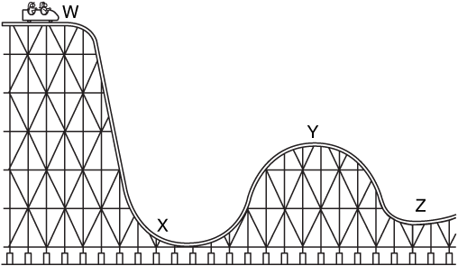Question **11** refers to the diagram of a rollercoaster below.

11. At which point on the rollercoaster does the cart have the **most** kinetic energy?

1. W
2. X
3. Y
4. Z

12. Which of the following best describes the energy changes occurring when an apple falls from a tree branch to the ground below?

1. gravitational potential → kinetic → sound
2. gravitational potential l→ elastic potential 🡪 sound
3. kinetic → sound → gravitational potential
4. elastic potential → sound→ kinetic

13. An object’s displacement is its position compared to its starting point. It has a size and a direction. A racehorse runs a race that starts and finishes at the same point. If the race was 1000 metres, what was the displacement of the horse when it finished?

1. 1000 metres
2. 500 metres
3. 10 metres
4. 0 metres

14. The racehorse now runs a second race but is unable to finish due to a sore leg and stops to a halt at a distance of 120 m east of the finish line. Given that the distance to be run in the race was 1000 m, and that the finish line was where the race started, the displacement of the racehorse is now:

1. 120 m east
2. 120 m west
3. 880 m east
4. 880 m west

15. Shown below is a displacement–time graph for Bob as he walks to a friend’s house and returns over a day.

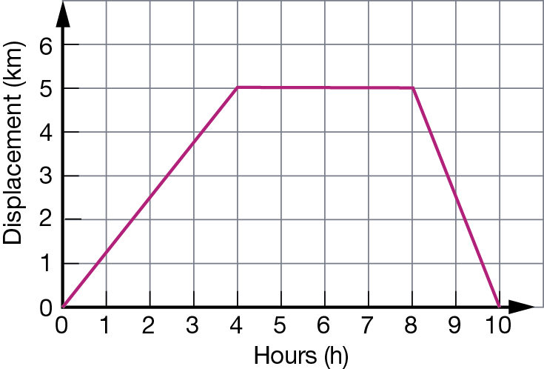

Which of the following statements concerning this journey is correct?

1. The total distance travelled for the journey was 5 km.
2. The total distance travelled for the journey was 10 km.
3. The total displacement for the journey was 5 km.
4. A one-hour rest break was made during the journey.



**Year 10**

**Science**

**Semester 1 Exam 2018**

**MULTIPLE CHOICE ANSWER SHEET**

**NAME:**

**FORM: DATE:**

**SECTION ONE: Multiple choice answers**

**Cross (X) through the correct answer.**

|  |  |  |  |  |  |  |  |  |  |  |
| --- | --- | --- | --- | --- | --- | --- | --- | --- | --- | --- |
| **1** | **X** | **b** | **c** | **d** |  | **13** | **a** | **b** | **c** | **X** |
| **2** | **a** | **X** | **c** | **d** |  | **14** | **X** | **b** | **c** | **d** |
| **3** | **a** | **b** | **X** | **d** |  | **15** | **a** | **X** | **c** | **d** |
| **4** | **a** | **b** | **c** | **X** |  |  |  |  |  |  |
| **5** | **X** | **b** | **c** | **d** |  |  |  |  |  |  |
| **6** | **a** | **b** | **c** | **X** |  |  |  |  |  |  |
| **7** | **a** | **X** | **c** | **d** |  |  |  |  |  |  |
| **8** | **a** | **b** | **X** | **d** |  |  |  |  |  |  |
| **9** | **X** | **b** | **c** | **d** |  |  |  |  |  |  |
| **10** | **X** | **b** | **c** | **d** |  |  |  |  |  |  |
| **11** | **a** | **X** | **c** | **d** |  |  |  |  |  |  |
| **12** | **X** | **b** | **c** | **d** |  |  |  |  |  |  |

**SECTION TWO - SHORT ANSWER SECTION** [29 marks]

This section has **6** questions. Answer **all** questions in the spaces provided. __________________________________________________________________________________________________________

**Question 1.**

* 1. Complete the following table: (4 marks)

|  |  |  |  |
| --- | --- | --- | --- |
| ELEMENT | ATOMIC NUMBER | ELECTRON SHELL DIAGRAM | ELECTRON CONFIGURATION |
| Oxygen | 8  (1/2 mark) | (1 mark) | 2, 6  (1/2 mark) |
| Oxide ion | 8  (1/2 mark) | ( 1 Mark) ½ for correct electrons ½ for brackets and charge | 2, 8  (1/2 mark) |

* 1. Identify **two differences** between the alkali metals and the noble gases:

(4 marks)

|  |  |
| --- | --- |
| Alkali metals | Noble gases |
| One electron in outer shell  Usually in solid form  Group 1  Highly reactive  (1 mark for any of above, 2 marks max) | Full and stable outer shell  Gaseous form  Group 18  Not reactive at all  (1 mark for any of above, 2 marks max) |

**Question 2.**

Consider the following pedigree for hair colour in mice. Mice can have either black coats (B) or brown coats (b). Black coats are dominant to brown.



Male Female

1. What is the genotype for brown coats? bb (1 mark)
2. Which individuals have brown coats? 4, 10 (1 mark)
3. How are individuals 10 and 11 related to each other? Brother and sister (1 mark)
4. Individuals 6 and 7 are 'carriers' of the brown allele. What is meant by the term carrier?

(2 marks)

The term carrier describes an organism that carries two different forms (alleles) of a recessive gene (alleles of a gene linked to a recessive trait) and is thus **heterozygous for that the recessive gene**. – **1 mark for recessive trait, having the allele, other mark for don’t have the condition however can pass it on.**

**Question 3.**

Having dimples (D) in your cheeks is dominant to having no dimples (d).

1. Write the possible genotypes and phenotypes for this trait. (3 marks)

Genotypes Phenotypes

½ mark each correct answer

DD Dimples

Dd Dimples

dd No Dimples

A heterozygous man, who has dimples, has children with a woman with no dimples.

1. Draw a Punnett square to show the potential offspring these two individuals can produce.

(2 marks)

|  |  |  |
| --- | --- | --- |
|  | D | d |
| d | Dd | dd |
| d | Dd | dd |

(1 mark for correct parent genotype, 1 mark for correct child possible genotypes)

1. What is the probability (%) that they produce a child with no dimples? 50 %

(1 mark)

**Question 4.**

Give one word or term for each of the following descriptions. Write only the word or term next to the question number. (4 marks)

1. A soccer ball at rest is then kicked across the field. This is an example of an energy…

Transfer (1 mark)

1. Someone turns on a light switch (which began as electricity and is seen as light) is an example of an energy….

transformation (1 mark)

1. State the law of conservation of energy:

**Energy** can neither be created nor destroyed, (1/2 mark) but can be transferred or transformed . (1/2 mark)

1. What is the formula for calculating energy efficiency

 (1 mark) energy output need useful output

**Question 5.**

Car racing is very popular in Australia. Many young people want to test the speed of their cars and meet regularly at racetracks. An oval racetrack has a lap distance of 2 000 m. The car has to complete 5 laps.

Use the graph to determine how long the car took to complete 2.5 laps. Indicate on your graph how you obtained this value. (2 marks)

125 - 130 seconds to complete 2.5 laps (1 mark) ½ correct number ½ unit

Line from 2.5 up to line graph (1/2)

, then a line from line graph to time on y axis 1/2) (Total1 mark)

**Question 6.**

**Work= f** x **d Gravitational Potential Energy (J) = m** x **g** x **h** where g=9.8 m/s

1. An elastic band is stretched back and then released. It travels a distance of 5 metres. If the force required to pull the elastic band was 5 Newtons, calculate the amount of work done. Show your working.

(2 marks)

W = f x d

= 5 x 5 (1 mark)

= 25 J or Joules (1 mark for correct answer AND correct unit of measurement)

1. Tony the firefighter has a mass of 90kg. He climbs up a 7 meter ladder to rescue a cat.

Calculate his gravitational potential energy. Show your working. (2 marks)

GPE = m x g x h

= 90 x 9.8 x 7 (1 mark)

= 6174 J or Joules (1 mark for correct answer AND correct unit of measurement)

**END OF PAPER**